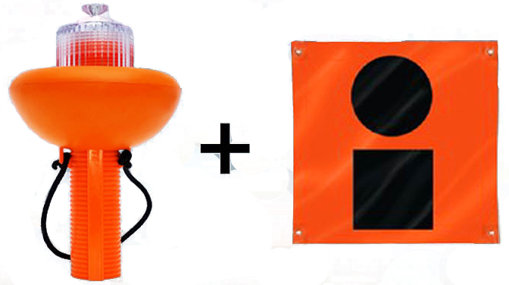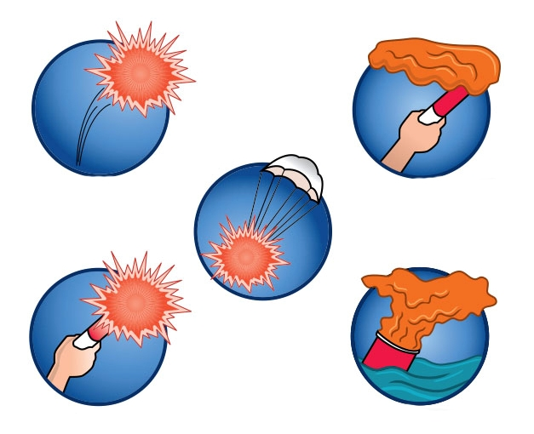

*\*This list is not exhaustive. In some cases Boating Safety Education Certificates and/or Watersports Flags are required. Always check USCG regulations before boating.*

Must carry one USCG-approved life jacket *per person aboard*. Check each one for accessibility, sizing and whistles. Children under 13 must always wear life jacket while aboard. All vessels over 16’ required to have one throwable flotation device.

Check USCG requirements for size and number. Must be USCG approved and marine specific. Charge and store properly.

**Fire Extinguisher**

**Sound Signaling Devices**

**First Aid Kit**

Check and replace any worn lines. Should be at least 5 – 7 times the water depth.

**Anchor with Anchor Line**

Purchase a kit that will fit your needs in a minor emergency.

A sound signaling device is required aboard all boats. To be used in fog, signaling bridges and in emergencies.

**Personal Flotation Devices**

All vessels are required to carry day/night time approved devices. Review proper use and storage.

**Coast Guard Compliant Marine Distress Signal Devices**

Use this list* and check your State requirements for local laws to be safe on the water.   
Call your local Power Squadron or Coast Guard Auxiliary for a Vessel Safety Check.

**U.S. COAST GUARD VISUAL DISTRESS SIGNAL REQUIREMENTS**

**SIRIUS SIGNAL**

**BOAT SAFETY CHECKLIST**

**What Are The Coast Guard Requirements For Marine Distress Signal Devices?**

Vessels over 16’ in length are required to carry visual distress signals. Non-pyrotechnic devices must automatically flash the SOS signal, have a light life of at least 6 hours and indicate that it meets the 46 CFR 161.013 requirements.  
 A device must be on all boats operated on the high seas, coastal waters, the Great Lakes, territorial seas and all waters directly connected to these, up to a point where the waters are less than two miles wide.  
 In addition to visual distress signals, all boats must have emergency sound signals as well.

**What Vessels Must Meet The Requirements?**

All boats must comply if on designated waters at night. Must have a combination day/night time device (flares) OR one each of day (flag, smoke signal) and nighttime devices (non-pyrotechnic).  
 During daytime operation, the following boats do not need to comply: (a) recreational boats less than 16 feet in length; (b) boats participating in organized events, such as races, regattas and parades; (c) open sailboats without propulsion machinery and less than 26 feet in length; (d) manually propelled boats.

**How Many Signals Does Each Vessel Need?**

Each boat needs *one non-pyrotechnic signal device* and one orange emergency flag to be Coast Guard compliant. A minimum of three pyrotechnic devices must be carried (recommended to carry more). Any combination of pyrotechnic devices can be used, but must equal three each for day and night use.

**What Are The Penalties For Failure To Comply?**

Pursuant to the Coast Guard regulations, the Coast Guard may issue a civil penalty up to $1,000. In the case of an emergency, the ability to signal others could directly affect the safety of you or loved ones.

### A GUIDE TO

### MARINE DISTRESS SIGNAL DEVICES

### IS YOUR

### VESSEL U.S.

### COAST GUARD COMPLIANT?

## Praesent congue sapien sit amet justo.

**Operation and Inspection:**

Acquaint yourself and all members aboard with emergency protocol and proper distress signal device use.  
 Before the boating season turn on your non-pyrotechnic device to make sure you know how it works and that the batteries are in good condition. If using pyrotechnic devices, check expiration dates and dispose of expired devices.

**Disposal:**

Your non-pyrotechnic (electronic) device never expires and can last the lifetime of your boat. Annually check and dispose of dead batteries.   
 Pyrotechnic devices expire 42 months after manufacturing and need to be disposed of properly to avoid danger to persons and environment. Check printed expiration dates and contact the manufacturer for advice on proper disposal of expired flares and flares that will expire in the upcoming boating season. Never throw expired devices overboard or in household trash.  
 WARNING: It is illegal to use flare launchers as weapons or for any use other than emergency distress signaling. User may be subject to civil or criminal action under State Firearm Laws.

**Use and Care:**

Your non-pyrotechnic device is waterproof and submersible. Store in an easily accessible location on your boat and make all members aboard aware of location.  
 Pyrotechnic devices need to be stored in a dry location on your boat. DO NOT store pyrotechnic devices loaded, as it may endanger those on the boat.

**USING MARINE**

**DISTRESS SIGNALS**

**U.S. COAST GUARD COMPLIANT**

**DAY AND NIGHT DISTRESS SIGNALS**

**USING MARINE   
DISTRESS SIGNAL DEVICES**

**Handheld Electronic Distress Signal Device**  
*Min. battery life:   
6 hrs.*  
(nighttime only)

**Minimum 36” Square Orange Flag***With black disk and square printed on both sides*  
(daytime only)

**ATTENTION:** Check your devices to make sure they clearly indicate Coast Guard compliancy. Only visual distress signals marked   
 with a U.S. Coast Guard approval or certification number meet the requirements.

**Approved Pyrotechnic Devices:**NOTE: Must carry a minimum of 3 day and 3 nighttime approved devices.

**Approved Non-Pyrotechnic Devices:***NOTE: carrying both these devices will meet all U.S. Coast Guard day and night requirements.*

Sirius Signal recommends using a non-pyrotechnic (electronic) distress signal device with an orange flag for your safety and maximum visibility in an emergency situation.   
Below are the U.S. Coast Guard approved devices:

**Floating Orange Smoke Flare***Min. burn time: 3 minutes*  
(daytime only)

**Handheld Red Flare***Min. burn time: 2 minutes*  
(day & nighttime)

**Red Meteor Aerial***Min. burn time: 5.5 seconds*  
(day & nighttime)

**Parachute Flare Aerial***Min. burn time: 30 seconds*  
(day & nighttime)

**Orange Smoke Flare***Min. burn time: 50 seconds*  
(daytime only)